**Day 1:**

question 1: pattern problem

def myfunc(n):

for i in range(0, n):

for j in range(0, i+1):

print("* ",end="")

print("\r")

n = 5

myfunc(n)

output:

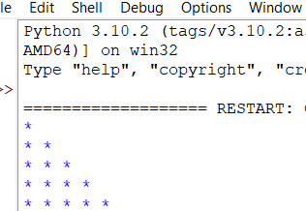

Q2.

CODE:

def myfunc(n):

k = n - 1

for i in range(0, n):

for j in range(0, k):

print(end=" ")

k = k - 1

for j in range(0, i+1):

print("* ", end="")

print("\r")

n = 5

myfunc(n)

OUT PUT:

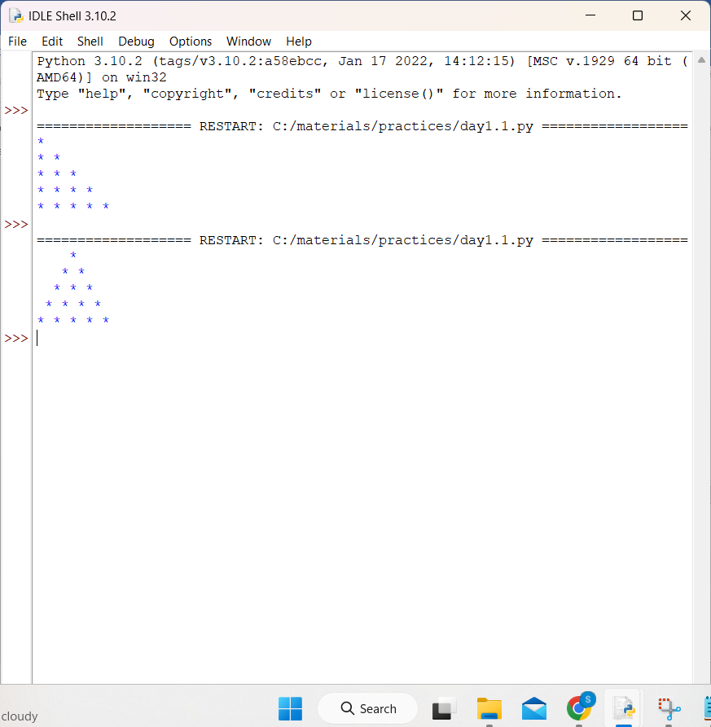

Q3. **find a fibonacci of a number.**

**CODE:**

**nterms = int(input("How many terms? "))**

**# 7**

**n1, n2 = 0, 1**

**count = 0**

**if nterms <= 0:**

**print("Please enter a positive integer")**

**elif nterms == 1:**

**print("Fibonacci sequence upto",nterms,":")**

**print(n1)**

**else:**

**print("Fibonacci sequence:")**

**while count < nterms:**

**print(n1)**

**nth = n1 + n2**

**n1 = n2**

**n2 = nth**

**count += 1**

**OUTPUT:**

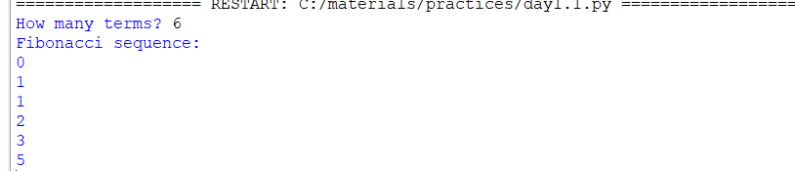

**Q4.** **find a factorial of a number.**

**Code:**

num = int(input("Enter a number: "))

factorial = 1

if num < 0:

print("Sorry, factorial does not exist for negative numbers")

elif num == 0:

print("The factorial of 0 is 1")

else:

for i in range(1,num + 1):

factorial = factorial*i

print("The factorial of",num,"is",factorial)

output:-



**Q5.** **strings are anagram or not.**

**Code:**

def check(s1, s2):

if(sorted(s1)== sorted(s2)):

print("The strings are anagrams.")

else:

print("The strings aren't anagrams.")

s1 = input("Enter string1: ")

# input1: "listen"

s2 = input("Enter string2: ")

# input2: "silent"

check(s1, s2)

output:-



**Q6.** **palindrome or not.**

**Code:**

num = int(input("Enter a number: "))

eg:// Input: 12321

temp = num

reverse = 0

while temp > 0:

remainder = temp % 10

reverse = (reverse * 10) + remainder

temp = temp // 10

if num == reverse:

print('Palindrome')

else:

print("Not Palindrome")

Output:

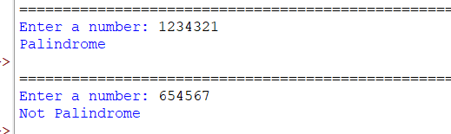

Q7. **prime or not.**

**Code:**

num = int(input("enter a number: "))

flag = False

if num > 1:

for i in range(2, num):

if (num % i) == 0:

flag = True

break

if flag:

print(num, "is not a prime number")

else:

print(num, "is a prime number")

out put:

